**Unveiling the Crypto Market: A Power BI Dashboard Guide**

The world of cryptocurrency is ever-evolving, presenting exciting opportunities alongside inherent risks. Navigating this dynamic market requires informed decision-making, and that's where data visualization comes in. This blog post introduces you to a powerful tool: a cryptocurrency dashboard built with Power BI.

This dashboard empowers you to visualize and analyze market data, gaining valuable insights into cryptocurrency performance and sentiment. Let's delve into each section of the dashboard and discover the treasure trove of information it offers.

**Tools and Technology Used**

Our dashboard was built using a combination of powerful tools and technologies:

* **Python:** Used for data extraction and preprocessing.
* **SQLite:** Chosen for efficient data storage and management.
* **Power BI:** Leveraged for dynamic visualization and analysis.

**Breakdown by Cryptocurrency**

Here, a prominent card visual displays the **current market price** giving you an instant snapshot of its value.

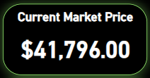

Understanding market price is crucial, as it reflects the current cost to acquire a particular cryptocurrency.

Dive deeper with a **line chart** that serves as a visual representation of the cryptocurrency's market price by day. By tracking price fluctuations over time, you can identify trends and potential entry or exit points (depending on your investment strategy).

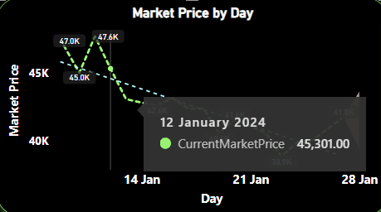

**Top Cryptocurrencies by Market Capitalization**

Ever wondered which cryptocurrencies dominate the market? This section features a comprehensive table showcasing the top 30 cryptocurrencies ranked by **market capitalization**.

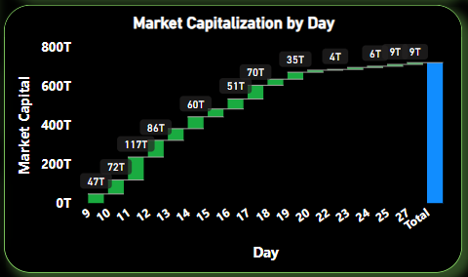

Each entry displays the cryptocurrency's name, symbol, and current market price.

Market capitalization refers to the total market value of a cryptocurrency, calculated by multiplying the circulating supply by the current market price. This metric helps gauge a cryptocurrency's overall influence and relative standing within the market. Consider adding a line chart (placeholder) to visualize the market capitalization by day for a specific cryptocurrency from the table. This can reveal how a cryptocurrency's market dominance fluctuates.

**Top Cryptocurrencies by Current Market Price**

Looking for the hottest cryptocurrencies based on current market value? This section provides a table listing the top 30 cryptocurrencies by current markt price.

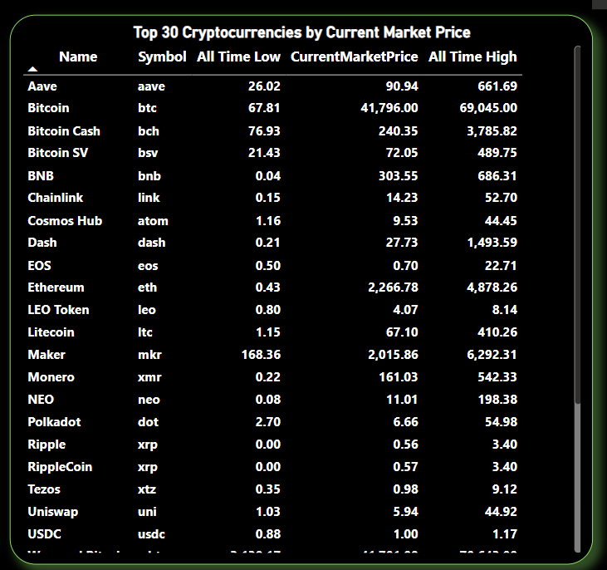

It includes additional valuable data points like the cryptocurrency's name, symbol, all-time low, current market price, and all-time high.

All-time highs and lows offer valuable context for understanding a cryptocurrency's historical performance. Analyzing these metrics alongside current market price can help you assess potential growth or risk.

**Average Sentiment Score by Year**

Public perception can significantly impact a cryptocurrency's value. This section sheds light on overall sentiment through a **line chart** displaying the average sentiment score by year.

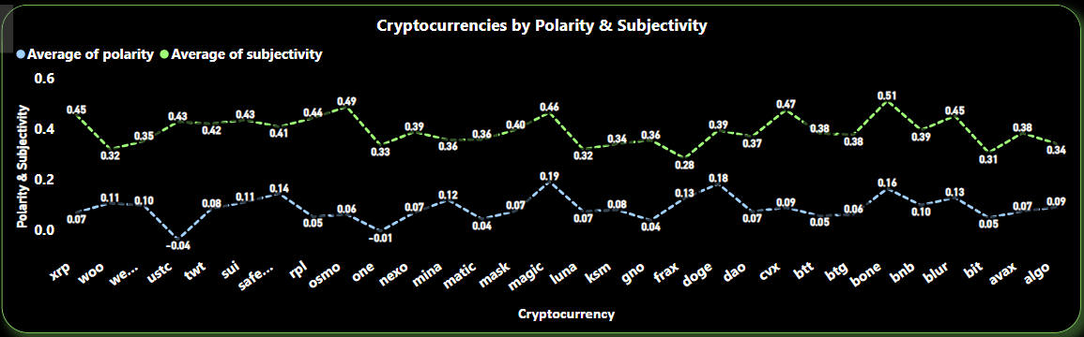

Sentiment analysis gauges the overall mood surrounding a cryptocurrency, analyzing news articles and social media posts. However, it's crucial to remember that sentiment analysis isn't perfect. Consider this data point alongside other market factors for a more comprehensive picture.

**Polarity and Subjectivity: A Deeper Dive**

This section takes a deeper dive into sentiment analysis, revealing the polarity and subjectivity scores of various cryptocurrencies.

**Top 10 Positive Sentiment Cryptos**

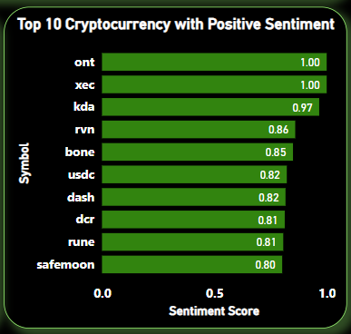

This bar chart lists the top 10 cryptocurrencies with the most positive sentiment scores, including their names and scores.

**Top 10 Neutral Sentiment Cryptos**

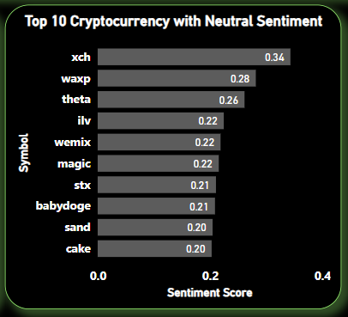

This bar chart showcases the top 10 cryptocurrencies with the most neutral sentiment scores, including their names and scores.

**Top 10 Negative Sentiment Cryptos**

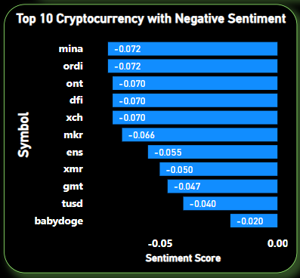

This bar chart lists the top 10 cryptocurrencies with the most negative sentiment scores, including their names and scores.

Polarity score indicates the sentiment leaning towards positive or negative, while subjectivity score reflects the language used (factual vs. opinion-based). Analyzing these scores alongside current market performance can offer valuable insights into how public perception might be influencing a cryptocurrency's value.

**Conclusion**

This cryptocurrency dashboard empowers you with a wealth of data points, all conveniently visualized for insightful analysis. By exploring market price fluctuations, market capitalization ranking, sentiment scores, and more, you gain a deeper understanding of the ever-changing cryptocurrency landscape. Remember, this dashboard is a valuable tool, but it shouldn't be your sole source of information. Combine its insights with other research methods to make informed investment decisions.

**Ready to explore the exciting world of cryptocurrency data visualization?** ( *** Dashboard link here ***)

This blog post has provided a roadmap for navigating your cryptocurrency dashboard